Lab Progams

24. Financial Data Line Chart

AIM
To write a Python program to plot the financial data of Alphabet Inc. using line charts for Open, High, Low, and Close values.

PROCEDURE
- Import matplotlib.pyplot.
- Store the financial data.
- Separate Date, Open, High, Low, and Close values.
- Plot each financial value using plt.plot().
- Add legends, axis labels, and title.
- Display the graph.

CODE — Run in Python IDLE
import matplotlib.pyplot as plt

# Financial data
date = ["10-03", "10-04", "10-05", "10-06", "10-07"]

open_price = [774.25, 776.00, 779.30, 779.78, 779.65]
high = [776.05, 779.77, 782.00, 778.75, 779.67]
low = [772.55, 772.88, 775.50, 776.85, 775.75]
close = [775.00, 777.78, 776.50, 778.66, 778.08]

# Plot lines
plt.plot(date, open_price, label="Open")
plt.plot(date, high, label="High")
plt.plot(date, low, label="Low")
plt.plot(date, close, label="Close")

# Labels and title
plt.xlabel("Date")
plt.ylabel("Price")
plt.title("Alphabet Inc. Financial Data")

# Display legend
plt.legend()

# Display graph
plt.show()

INPUT
Date Open High Low Close
10-03 774.25 776.05 772.55 775.00
10-04 776.00 779.77 772.88 777.78
10-05 779.30 782.00 775.50 776.50
10-06 779.78 778.75 776.85 778.66
10-07 779.65 779.67 775.75 778.08

OUTPUT
A line chart containing four lines:
- Open
- High
- Low
- Close
with Date on the X-axis and Price on the Y-axis.
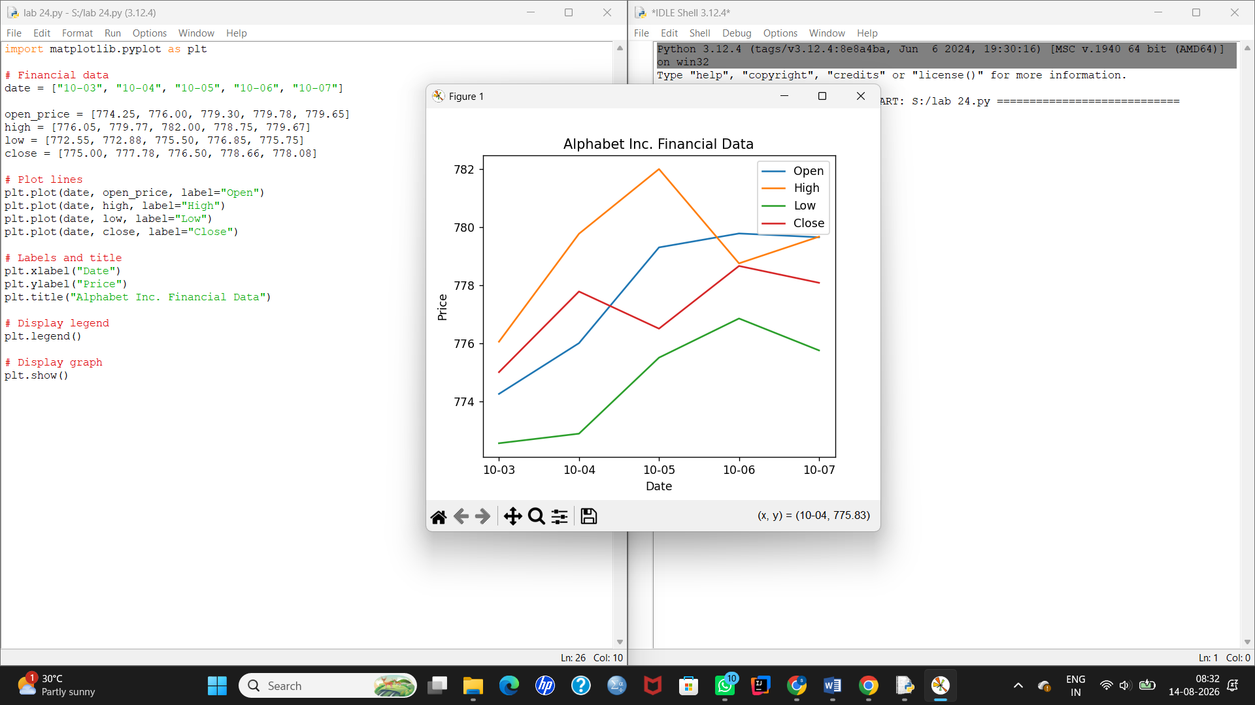

25. Plot Two or More Lines

AIM
To write a Python program to plot two or more lines with different colors, widths, and suitable legends.

PROCEDURE
- Import matplotlib.pyplot.
- Create X-axis values.
- Create values for two lines.
- Use plt.plot() with different colors and line widths.
- Add legends and axis labels.
- Display the graph.

CODE — Run in Python IDLE
import matplotlib.pyplot as plt

# X-axis values
x = [10, 20, 30]

# Y-axis values
y1 = [20, 40, 10]
y2 = [40, 10, 30]

# Plot two lines
plt.plot(x, y1, color="blue", linewidth=3, label="line1-width-3")
plt.plot(x, y2, color="red", linewidth=3, label="line2-width-3")

# Labels and title
plt.xlabel("x - axis")
plt.ylabel("y - axis")
plt.title("Two or more lines with different widths and colors")

# Legend
plt.legend()

# Display
plt.show()

INPUT
X = 10, 20, 30

Line 1 = 20, 40, 10
Line 2 = 40, 10, 30

OUTPUT
A graph containing two lines:
- Blue line → Line 1
- Red line → Line 2
The graph also displays the legend and axis labels.
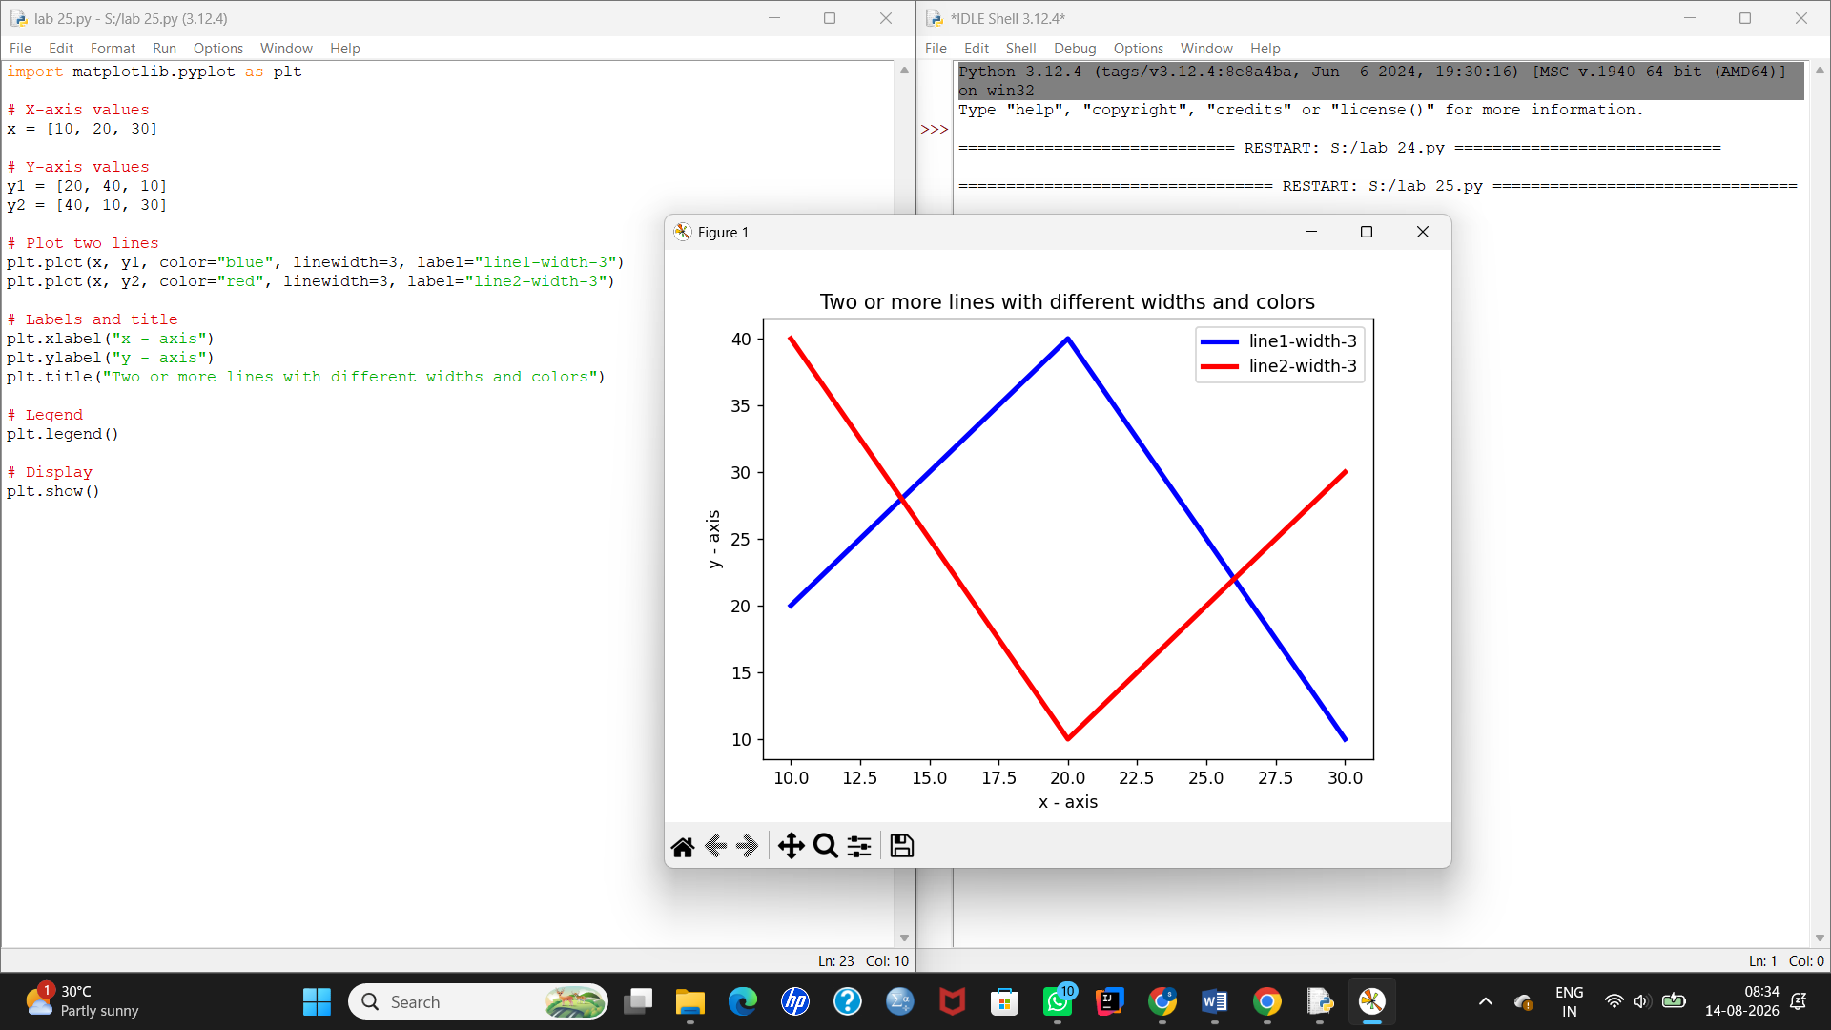

26. Create Multiple Plots

AIM
To write a Python program to create multiple plots in a single figure using Matplotlib.

PROCEDURE
- Import matplotlib.pyplot.
- Create a figure using plt.figure().
- Create multiple subplot areas using add_subplot().
- Plot different data in each subplot.
- Add titles to the plots.
- Display the complete figure using plt.show().

CODE — Run in Python IDLE
import matplotlib.pyplot as plt

# Create a figure
plt.figure(figsize=(8, 6))

# First plot
plt.subplot(2, 2, 1)
x = [1, 2, 3, 4]
y = [10, 20, 15, 25]
plt.plot(x, y)
plt.title("Line Plot")

# Second plot
plt.subplot(2, 2, 2)
x = [1, 2, 3, 4]
y = [5, 15, 10, 20]
plt.bar(x, y)
plt.title("Bar Plot")

# Third plot
plt.subplot(2, 2, 3)
x = [1, 2, 3, 4]
y = [10, 15, 20, 25]
plt.scatter(x, y)
plt.title("Scatter Plot")

# Fourth plot
plt.subplot(2, 2, 4)
x = [1, 2, 3, 4]
y = [25, 20, 15, 10]
plt.plot(x, y)
plt.title("Another Line Plot")

# Adjust layout
plt.tight_layout()

# Display
plt.show()

INPUT
Plot 1:
X = 1, 2, 3, 4
Y = 10, 20, 15, 25

Plot 2:
X = 1, 2, 3, 4
Y = 5, 15, 10, 20

Plot 3:
X = 1, 2, 3, 4
Y = 10, 15, 20, 25

Plot 4:
X = 1, 2, 3, 4
Y = 25, 20, 15, 10

OUTPUT
A single window containing four different plots:
